A Report On

# “Dues Notification System”

Submitted to

## Chhattisgarh Swami Vivekanand Technical University, Bhilai

### Bachelor of Engineering

In

### Computer Science & Engineering

By

**Yash Gedam**

**Sristi Arora**

Under the Guidance of

### Mr. Prageet Bajpai, Assistant Professor



**Department of Computer Science & Engineering Shri Shankaracharya Group of Institutions (Faculty of Engineering & Technology)**

**Shri Shankaracharya Technical Campus, Junwani, Bhilai Session :-** 2017-2021

**Abstract**

When a student is imposed with some fine, they does not get notified or does not get any notice about it. This may leads to increases fine. This particular issue demands a solution in the form of a system that is able to alert about imposed fine for avoiding increased fine.

Whenever admin impose fine on any student, he/she get notified by the message sent on their personal number. They are also notified when their last date of fine paying comes. Students and admin both can see student’s last fine transactions along with the fine type and last date.

**Table Of Content**

|  |  |  |
| --- | --- | --- |
| **Serial no.** | **Topic** | **Page No.** |
| 1 | Introduction   1. Objective 2. Scope |  |
| 2 | Requirement Specification   1. Hardware requirement 2. Software requirement 3. Module requirement |  |
| 3 | Methodology   1. Flow Diagram 2. Screen Shots |  |
| 4 | Result and Discussion |  |
| 5 | Conclusion and Future Enhancement |  |
| 6 | Bibliography/References |  |

**Chapter-1**

**Introduction**

**Objective**

College fine is something every student has experienced at least once in our life, where almost every student forgets to pay it on time. It is not a big issue if it is paid on time, but if it is not then the last fee keep on added in the fine and the fie amount so big that students get irritated.

This project, discusses about a system that can alert the student about the imposed fine and also keep previous paid/unpaid fine details.

**Project Scope**

* College can maintain the data of every student and their previously imposed fines.
* Notifications are sent to the student who is imposed with the fine at the instant when the fine is imposed.
* The system has scope for improvement / amendments.
* Students can see their all previously imposed fines.
* This system can be modified from time to time as per the changing requirement of the user with lesser cost also the backend of the system can be changed as per the storage requirement of the system and to provide more security level features.

**Chapter-2**

**Requirement Specification**

**Hardware Requirement**

* **Monitor**

A monitor is an electronic output device that is also known as video display terminal (VDT) or a video display unit (VDU). It is used to display images, text, video, and graphics information generated by a connected computer via a computer’s video card. Although it is almost like a TV, its resolution is much higher than a TV.

* **Keyboard**

A keyboard is one of the primary input devices that allow users to input text into a computer or any other electronic machinery. It is a peripheral device that is the most basic way for the user to communicate with a computer. It consists of multiple buttons, which create numbers, symbols, and letters, and special key like the Windows and Alt key, including performing other functions. The design of the keyboard comes from the typewriter keyboard, and numbers and letters are arranged on the keyboard in that way, which helps to type quickly.

* **Mouse**

A mouse is a small hardware input device used by hand. It controls the movement of the cursor on the computer screen and allows users to move and select folders, text, files, and icons on a computer. It is an object, which needs to put on a hard-flat surface to use. When the users move the mouse, the cursor moves in the same direction on the display screen. The name mouse is derived from its size as it is a small, cored, and elliptical shape device that looks a bit like a mouse. A connecting wire of a mouse is imaginable to be the mouse’s tail. Additionally, some of the mouse have combined features like extra buttons, which may be assigned and programmed with many commands. The mouse invention is considered as one of the most important breakthroughs in the computer field as it helps to reduce the use of a keyboard.

* **Android Phone**

An android phone is a powerful, high-tech smart-phone that runs on the android operating system (OS) developed by Google and is used by the various mobile phone manufacturers.

Android is a software package and linux based operating system for mobile devices such as tablets and smart-phones.

We need android phone for this project to access the website by the students from anywhere and for receiving the SMS sent by this website.

**Software Requirement**

* **HTML**

HTML is an acronym which stands for Hyper Text Markup Language which is used for creating web pages and web applications.

Hyper Text simply means “Text within Text”. A text has a link within it, is a hypertext. Whenever you click on a link which brings you to a new webpage, you have clicked on a hypertext. Hyper Text is a way to link two or more web pages (HTML documents) with each other.

A markup language is a computer language that is used to apply layout and formatting conventions to a text document. Markup language makes text more interactive and dynamic. It can turn text into images, tables, links, etc.

* **CSS**

CSS stands for Cascading Style Sheets. It is a style sheet language which is used to describe the look and formatting of a document written in markup language. It provides an additional feature to HTML. It is generally used with HTML to change the style of the web pages and user interfaces. It can also be used with any kind of XML document including plain XML, SVG and XUL.

CSS is used along with HTML and JavaScript I most websites to create user interfaces for web applications and user interfaces for many mobile application.

* **JavaScript**

JavaScript (js) is a light weight object-oriented programming language which is used by several websites for scripting the web pages. It is an interpreted, full-fledged programming language that enables dynamic interactivity on websites when applied to an HTML document. With JavaScript, users can build modern web applications to interact directly without reloading the page every time.

* **Bootstrap**

Bootstrap is the most popular HTML, CSS, and JavaScript framework for developing a responsive and mobile friendly website.

It is absolutely free to download and use.

It is a front-end framework used to easier and faster web development.

It includes HTML and CSS based design templates for typography, forms, buttons, tables, navigation, modals, images carousels and many others.

It can also use JavaScript plug-ins.

It facilitates you to create responsive designs.

* **MySQL**

MySQL is an open-source relational database management system. As with other relational databases, MySQL stores data in tables made up of rows and columns. Users can define, manipulate, control, and query data using Structured Query Language, more commonly known as SQL.

**Modules Requirement**

* **SMS Module**

This SMS module is developed and provide by smslane.com. This module is convenient to send SMS in an easier way.

**Chapter-3**

**Methodology**

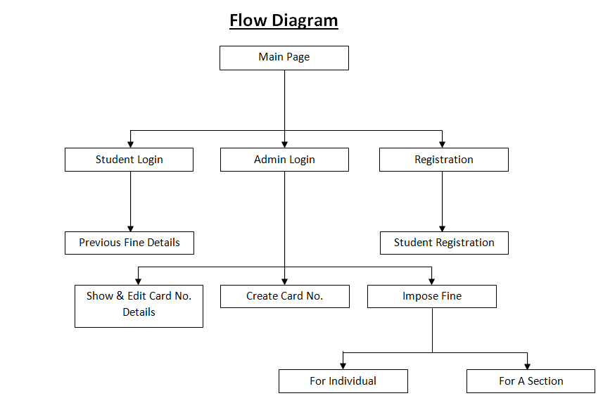

**Screen Shots**

1. **Main Page :**

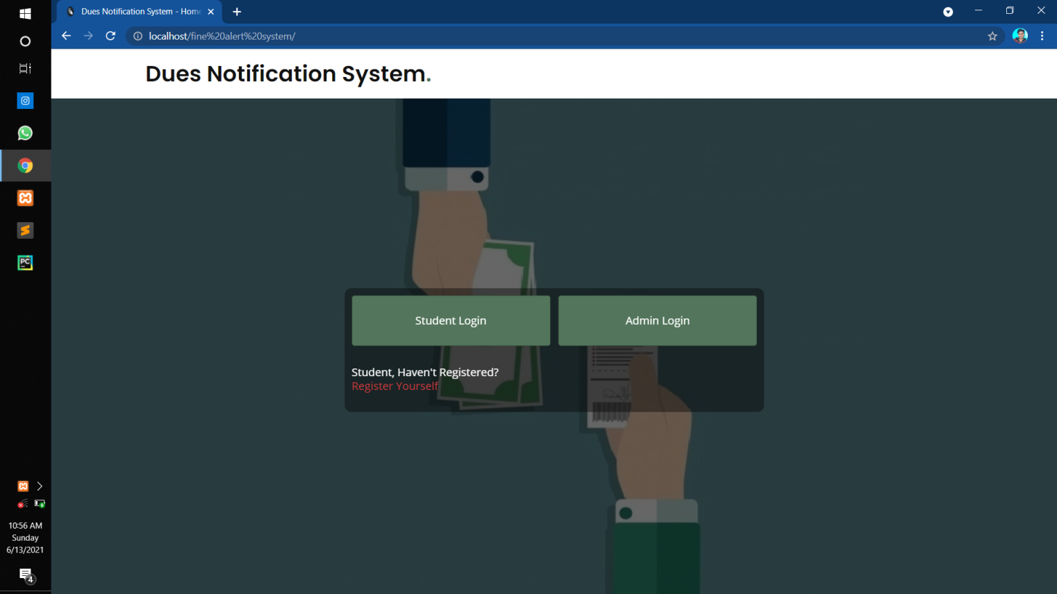

**Main page contain Student Login, Admin Login and Student Registration.**

**NOTE- There is no Admin Registration, so that no other unauthorized person can’t login in admin section.**

1. **Student Login**

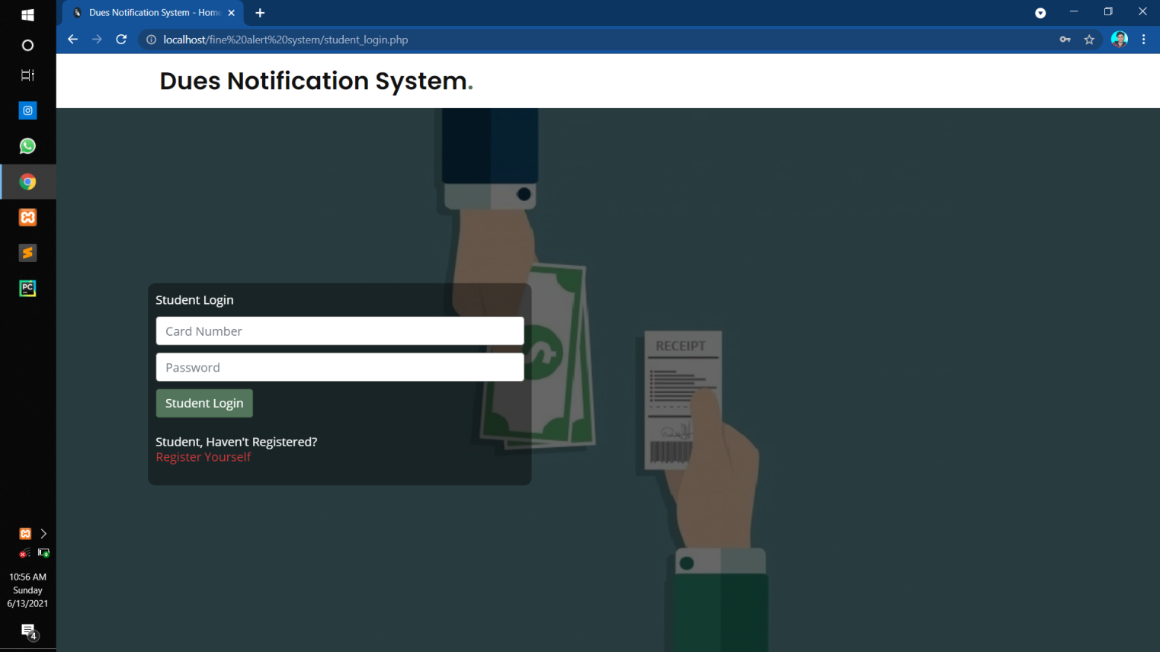

**Student will login with Card Number and Password credentials which will be provided after registrations through SMS.**

1. **Admin Login**

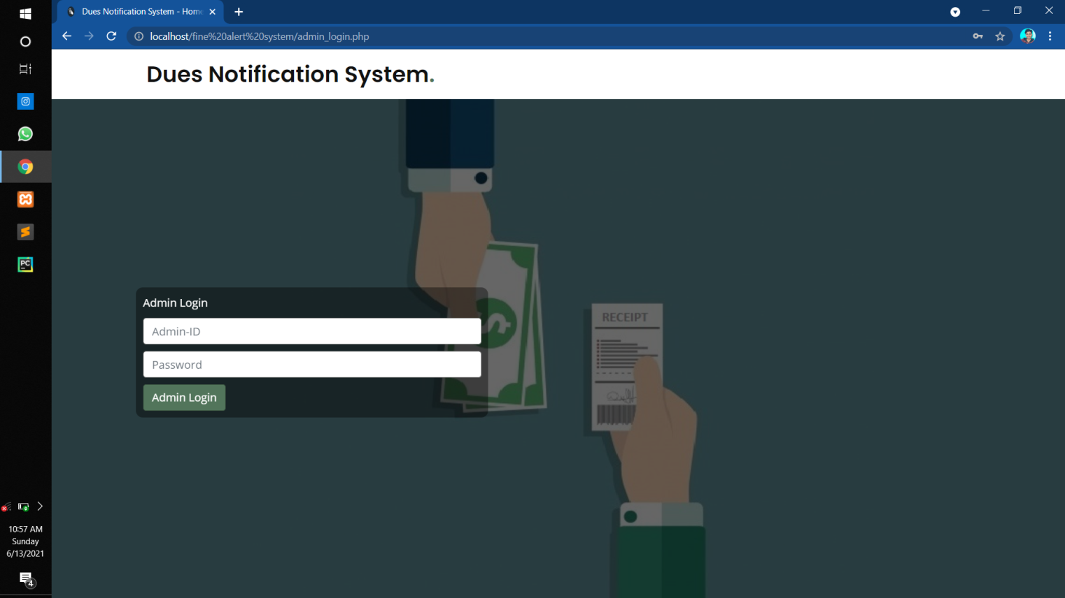

**Only one Admin will login with Admin ID and Password credentials that are pre-set in the database.**

1. **Student Registration**

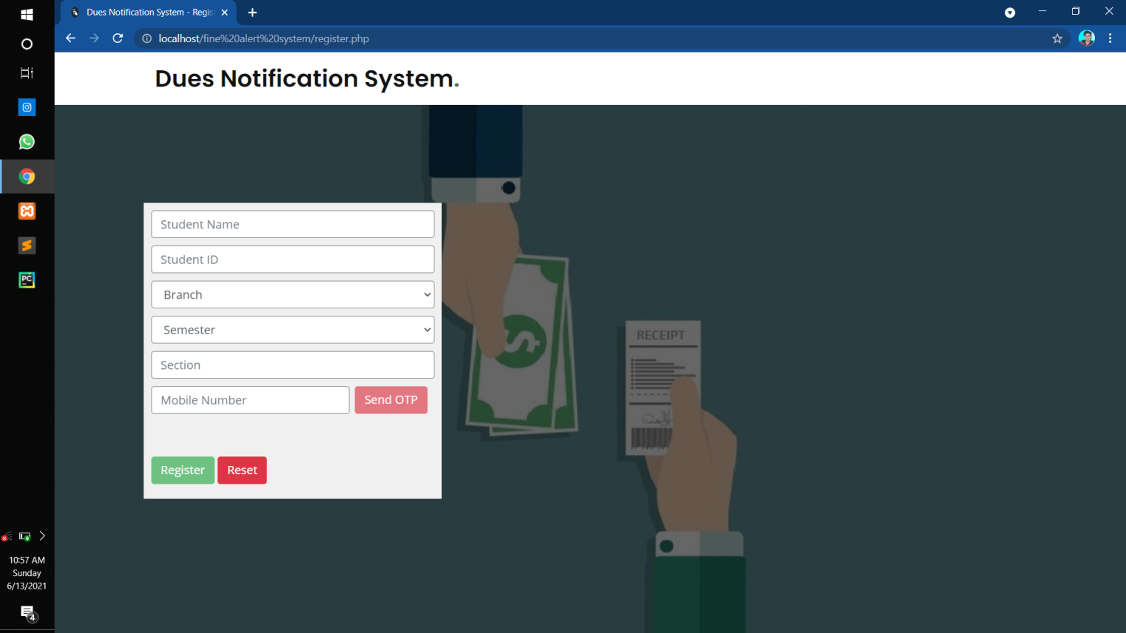

**For Student Registration, students have to give his name, student ID, branch, semester, section and mobile number.**

**To validate the mobile number, a 5-digit One Time Password (OTP) will be sent on that number.**

**Once all the given information is given and Register button is clicked, a SMS is sent on the given mobile number regarding successful registration provided with Card Number and Password for login.**

1. **Admin Page**

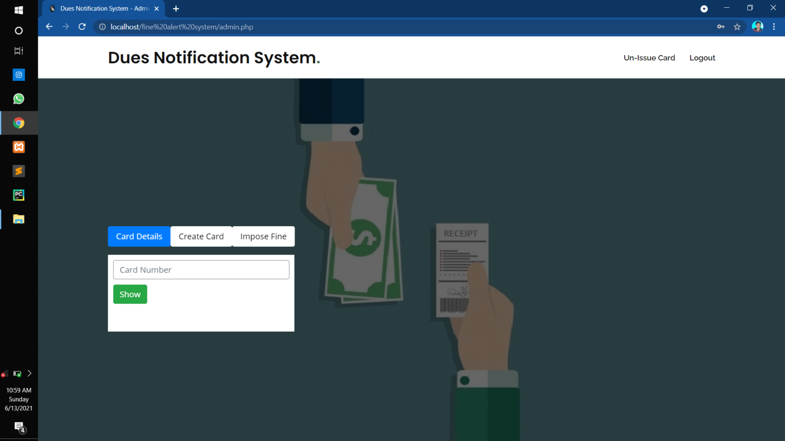

**After Admin logged in, layout shown above will be displayed. Here we have Student Details, Create Card and Impose Fine options.**

**Now we will discuss every option in detail.**

**5a. Card Details**

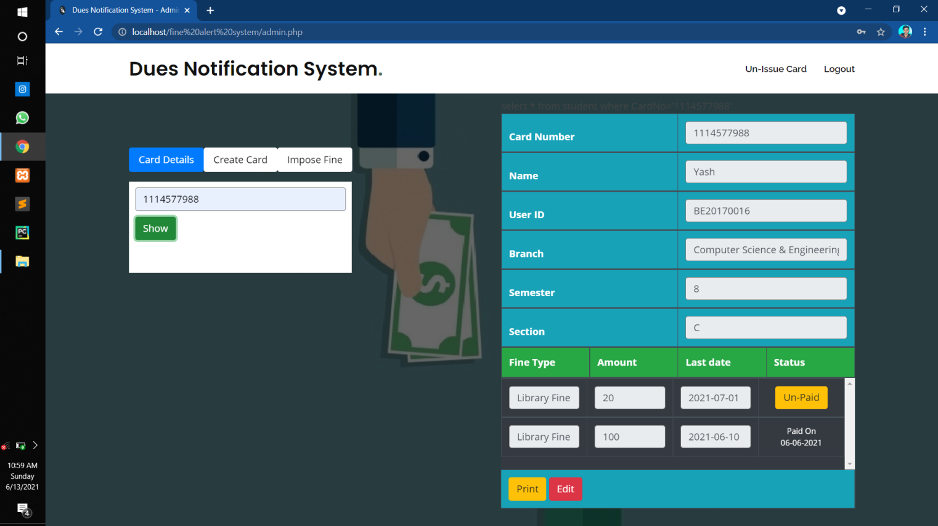

**In this option, when we enter the registered card number and press button show, a layout shown in right side of the screen shot is displayed.**

**Here we can see all the details of a particular student like Card Number, Name, User ID, Branch, Semester, Section and different fine details such as Fine Type, Amount , Last Date of Fine Paying and Status of that particular fine (Un-Paid / Paid with date).**

**We can edit the details of the students, can take the printout of the whole detail with all the paid/un-paid fine details.**

**When student will come to admin to pay the particular fine, admin will press the button Un-Paid next to that fine. Once clicked it will ask for the confirmation and once getting confirmed, the fine will be paid.**

**A SMS will be sent on the registered mobile number whenever fine is been paid of that particular student .**

**The fine will increase by Rs. 25 when the current date will exceed the last date of paying fine.**

**5b. Create Card**

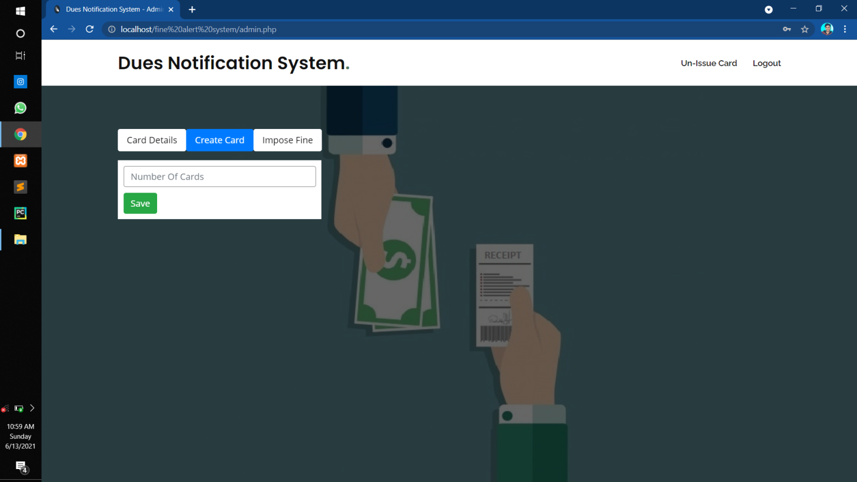

**Create Card is the option for creating a 10-digit card number randomly for future issuing the card to the students during registration.**

**We have to give the number of cards to be created as input and on the click of the Save button, that particular number of 10-digit card numbers are saved in the database.**

**5c. Impose Fine**

**Impose Fine have two sub-divisions:**

1. **Fine For Individual**

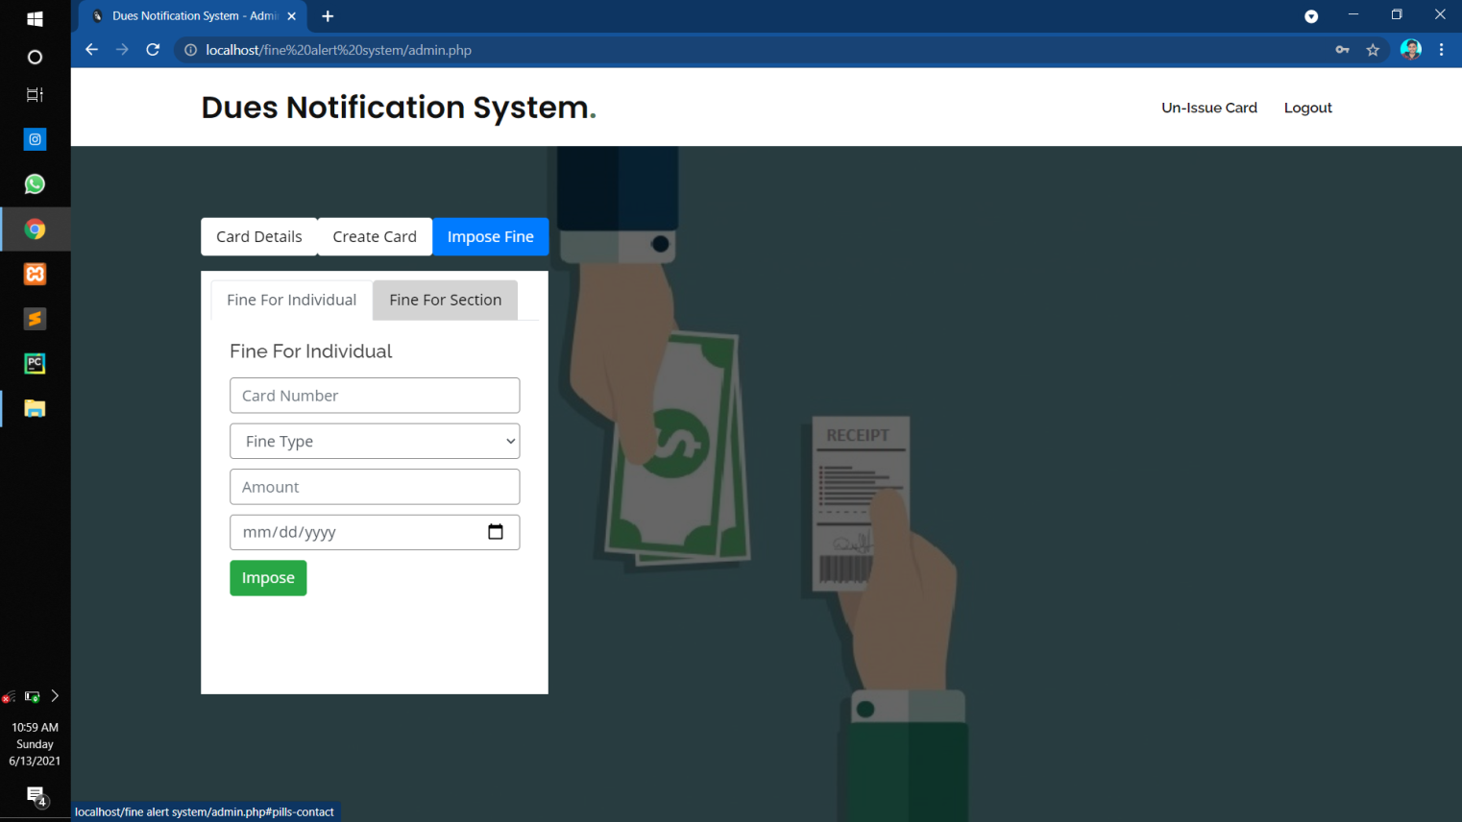

**In this division, fine on a particular student will be imposed.**

**Here admin will enter the card number of that student, Fine Type (Late Fee, Library Fine, Lab Fine), Fine Amount and the last date.**

**On giving all the details and pressing the Impose button, fine will be imposed and a SMS will the sent on that student’s registered mobile number.**

1. **Fine For whole section**

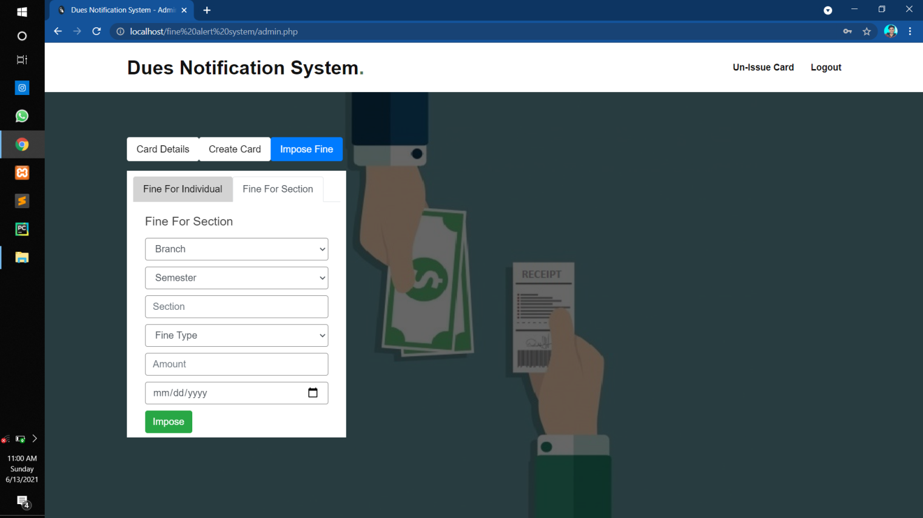

**In this division, fine on a whole section of a particular branch will be imposed.**

**Here admin will enter the Branch, Semester, Section, Fine Type (Late Fee, Library Fine, Lab Fine), Fine Amount and the last date.**

**On giving all the details and pressing the Impose button, fine will be imposed and a SMS will the sent on the student’s registered mobile number of that particular section of a particular branch.**

1. **Student Page**

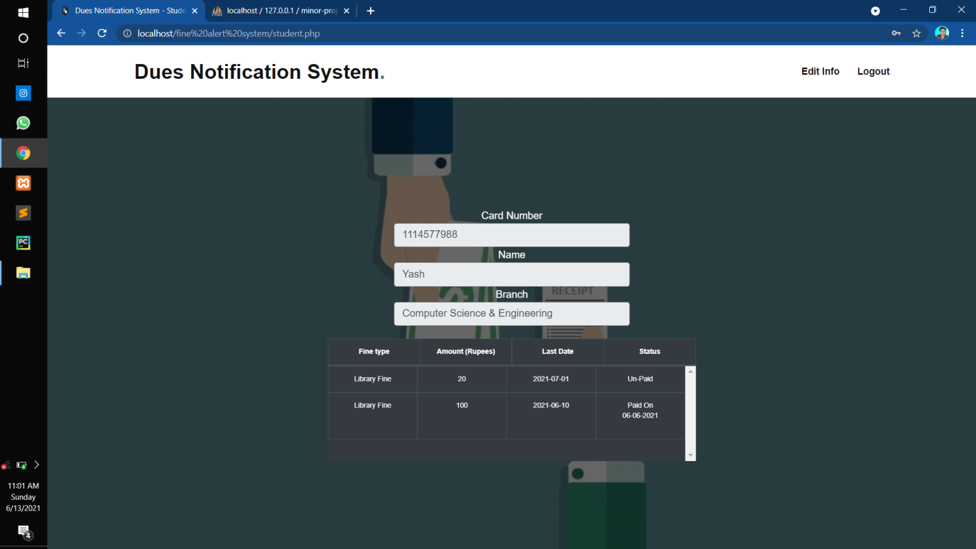

**In student page, student can see his Card Number, Name, Branch and every single paid/un-paid fine he is been imposed with.**

**He can only edit his mobile number and can change password from this page. All other changes will be done by admin if student wants to edit it.**

**Chapter-4**

**Result and Discussion**

**Discussion**

* College can maintain the data of every student and their previously imposed fines.
* Notifications are sent to the student who is imposed with the fine at the instant when the fine is imposed.
* The system has scope for improvement / amendments.
* Students can see their all previously imposed fines.
* This system can be modified from time to time as per the changing requirement of the user with lesser cost also the backend of the system can be changed as per the storage requirement of the system and to provide more security level features.

**Chapter-5**

**Conclusions and Possible Future Enhancements**

**Conclusion**

The website we designed in such a way that future modification can be done easily. The following conclusion can be deduced from the development of the project

* Automation of entire system improves the efficiency.
* It is better and faster than the existing system.
* Updating of information becomes so easy.
* It effectively overcome the delay in notification.

**Possible Future Enhancements**

* A bar code can be added to every card for easier and faster login.
* Payment model can be added.
* Database can be modified or changed as per the requirement

**Chapter-6**

**Bibliography / References**

**Reference**

1. [**https://en.wikipedia.org/wiki/Wikipedia**](https://en.wikipedia.org/wiki/Wikipedia)
2. [**https://stackoverflow.com/**](https://stackoverflow.com/)
3. [**https://www.w3schools.com/**](https://www.w3schools.com/)
4. [**https://www.smslane.com/**](https://www.smslane.com/)